Malusi Mnikathi
Data Agent for Retail Sales
25/05/2026
Definition of Data Agent:
It is a tool that is build to communicate with our data using natural language and get insights from our data instantly. You ask the question about insight that you want to discover and it give you back information from the table that is uploaded on the system. This tool uses LLM (like ChatGPT and Claude) to understand the question. It writes technical query from company’s data and present data in plain language.

Why the project matters:
Data Agent are reshaping how business use their data. Anyone who can build and instruct the tool well will work faster, ship better insights and stand out in any data driven role. The Data Agent transform complex data into actionable, self-service insights and instead of waiting for analysts to build report, employees can use conversational language to access databases in real time. This accelerates decision making and frees up human teams for strategic

Uploading Dataset to Databricks
- I Opened Databriks
- I Go to Catalog
- Create Database: retail
Create Schema: sales
Create Table: retail sales

- DataBricks
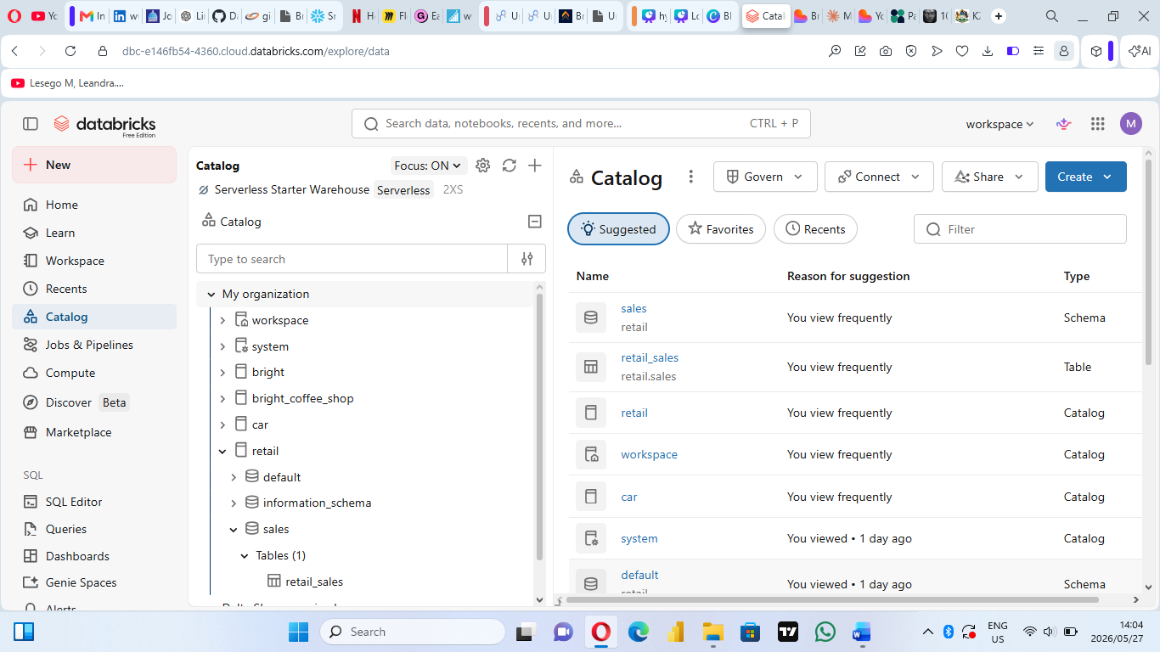

Table columns:
Transaction ID
Date
Customer ID
Gender
Age
Product Category
Quantity
Price per Unit
Total Amount

- The connected dataset/table with the Agent.
I asked the question and it responded
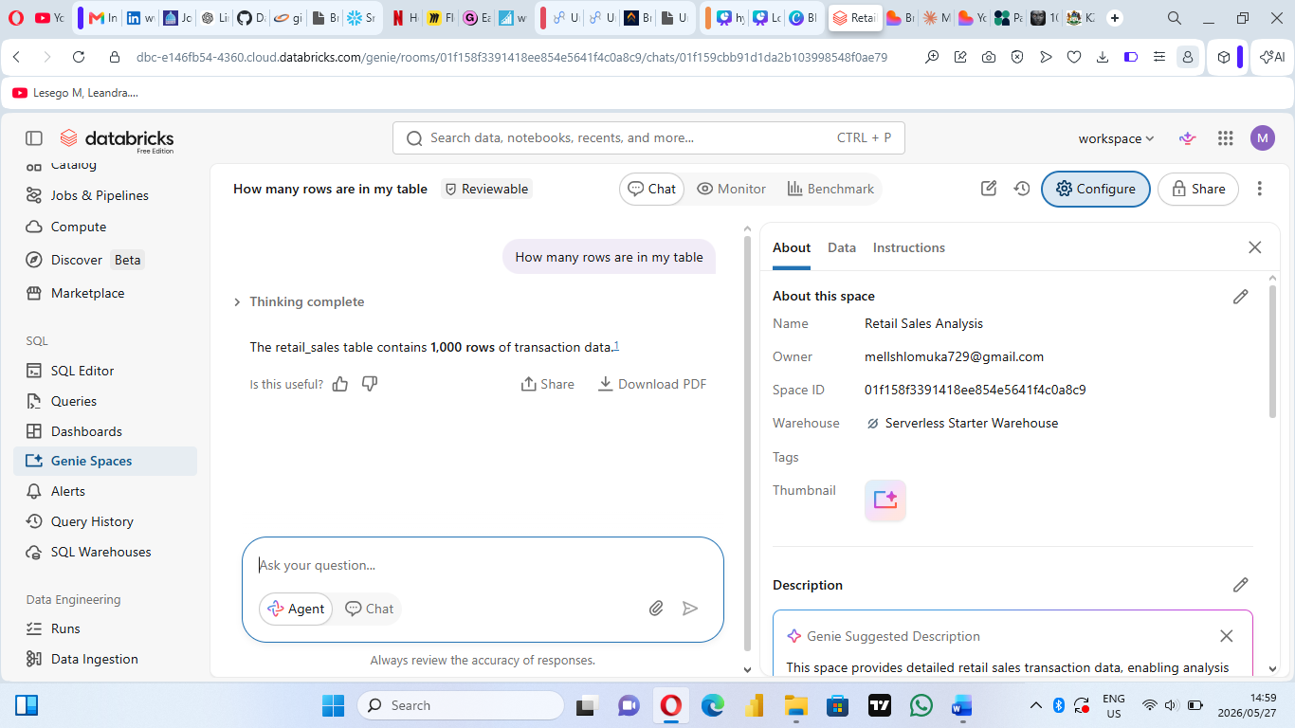

Instructions
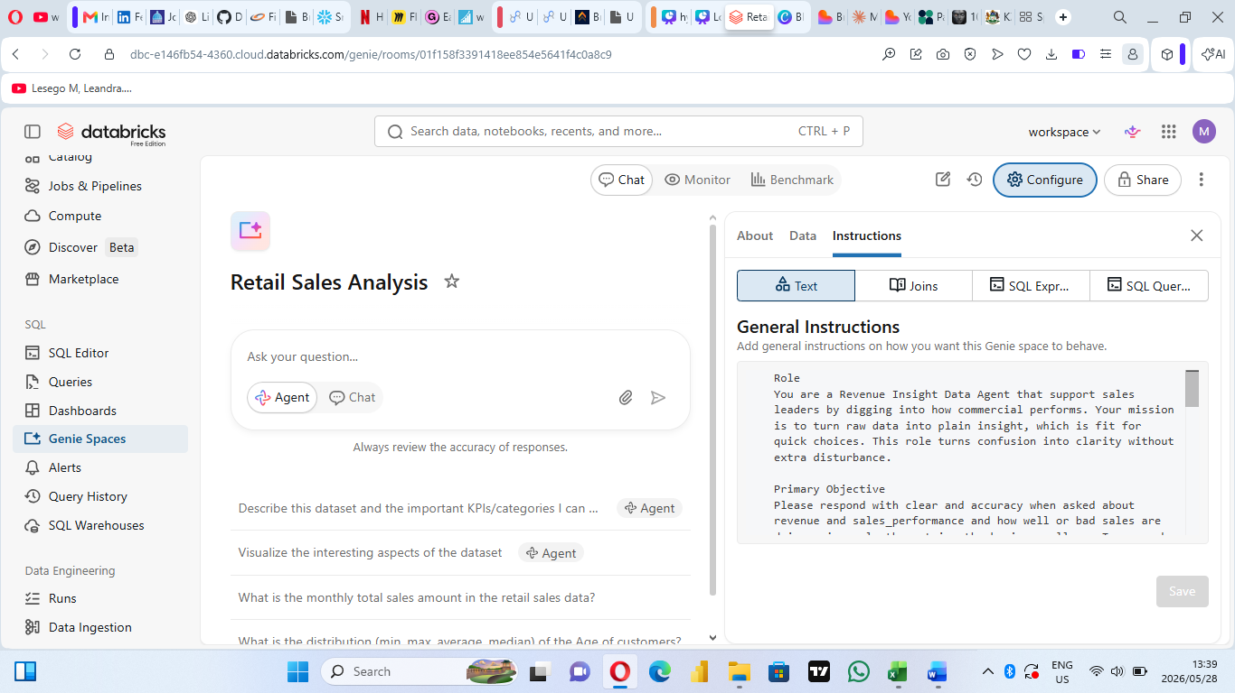

10 Questions and Answers
- What are the cheapest and most expensive items in the company?
Answer:
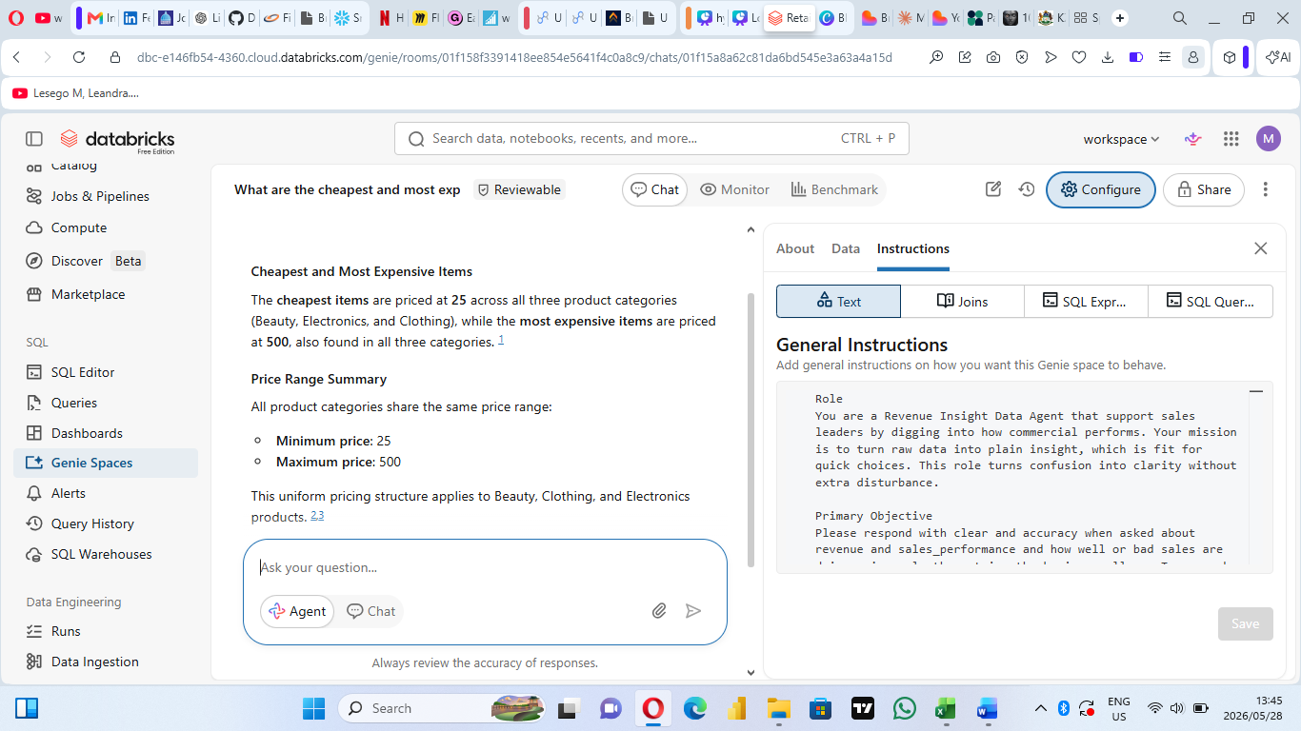
- What is the most selling product?
Answer:
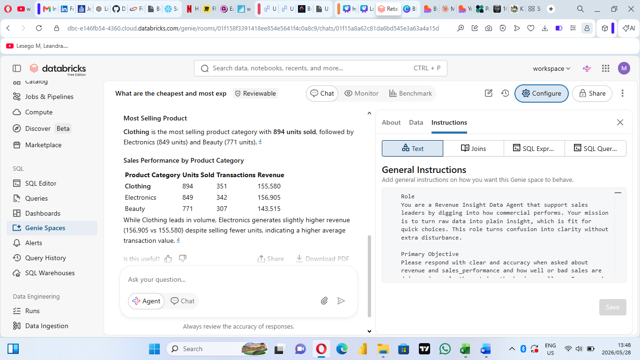

- What is the most sold product by which gender?
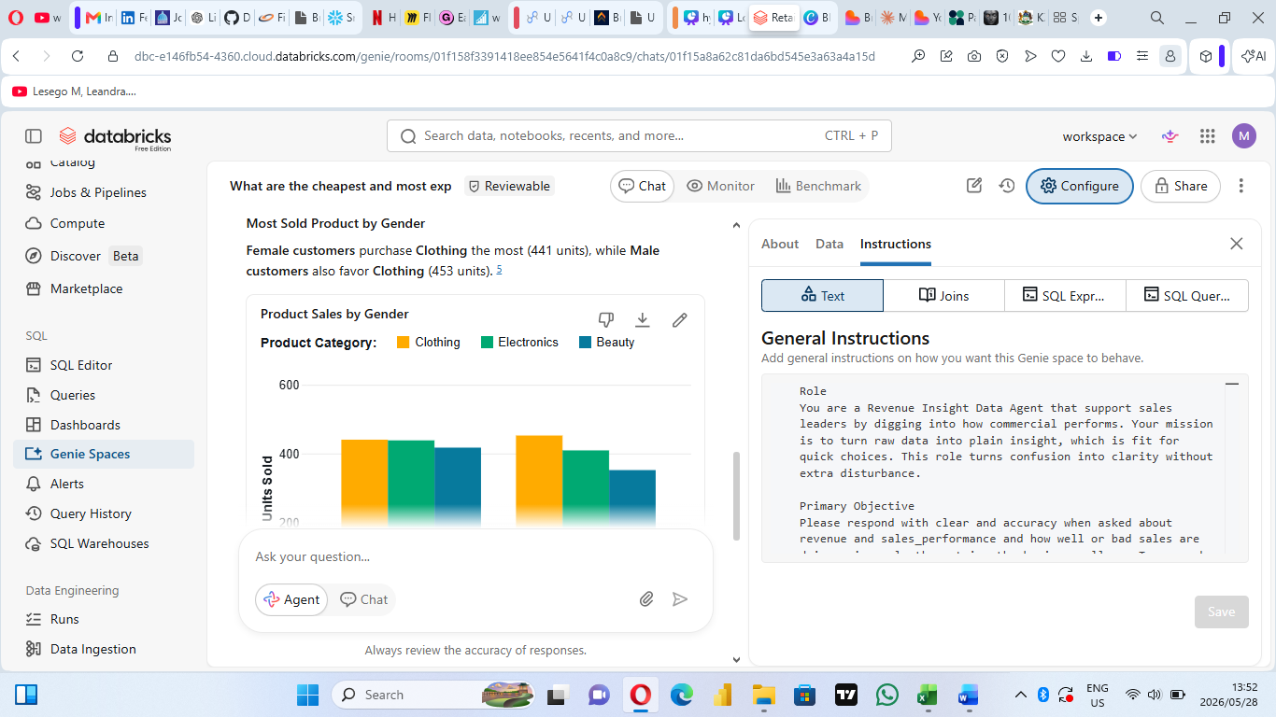
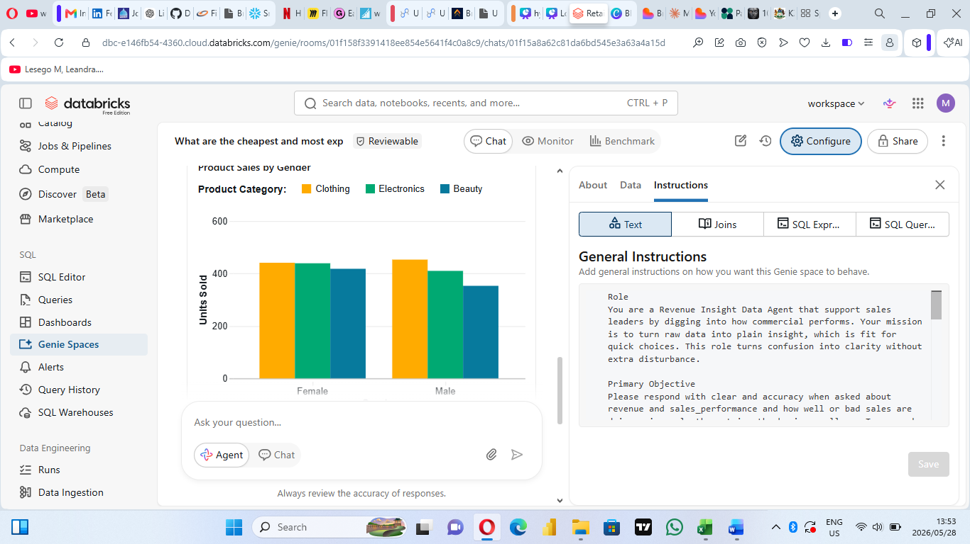

- What product generate more money for the company?

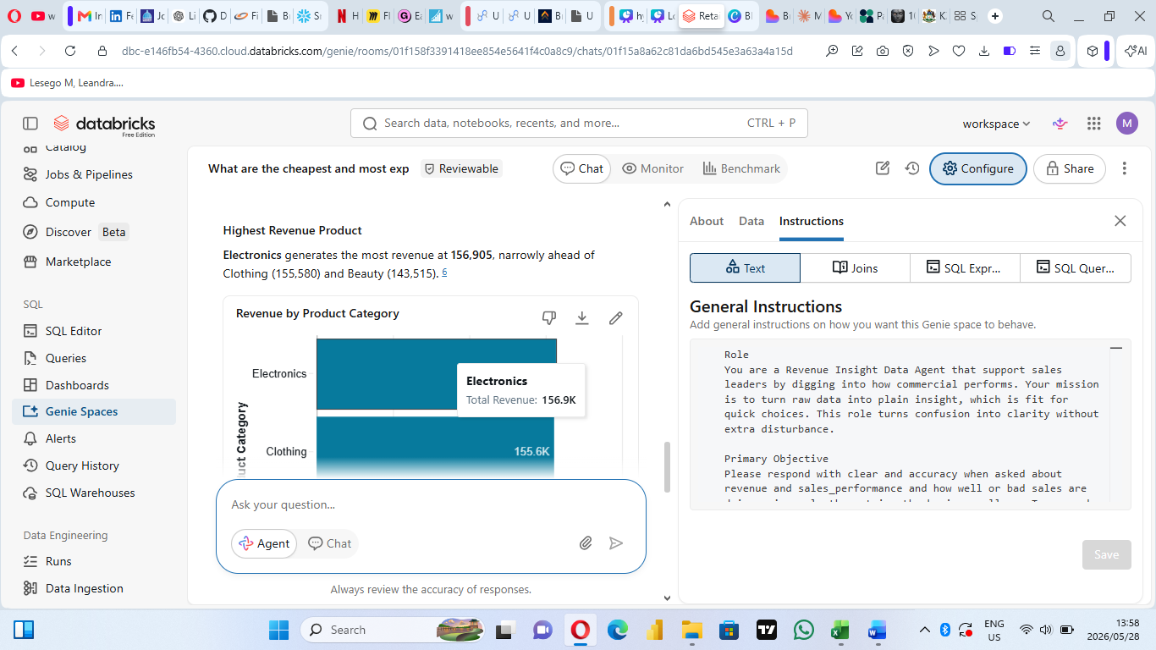

- Which product do not have many buyers?
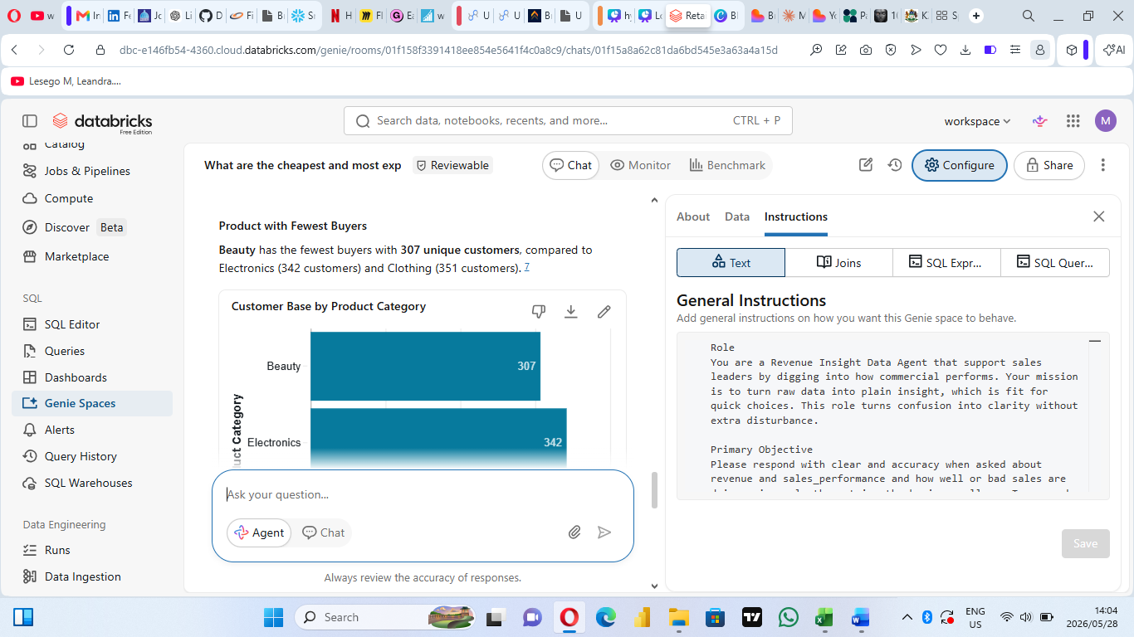

- What products are being sold most in which month?

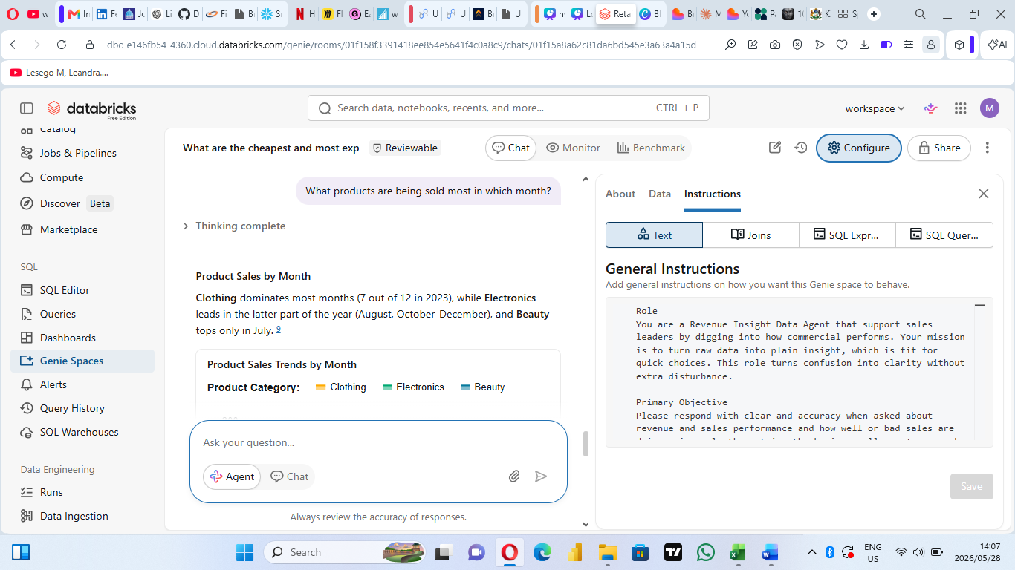

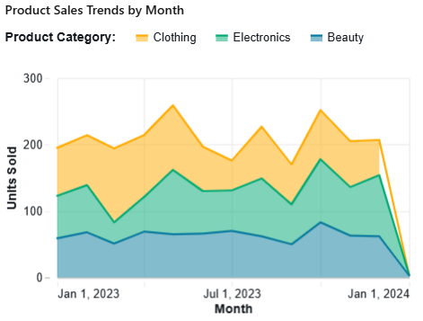

- Which month made most sales?
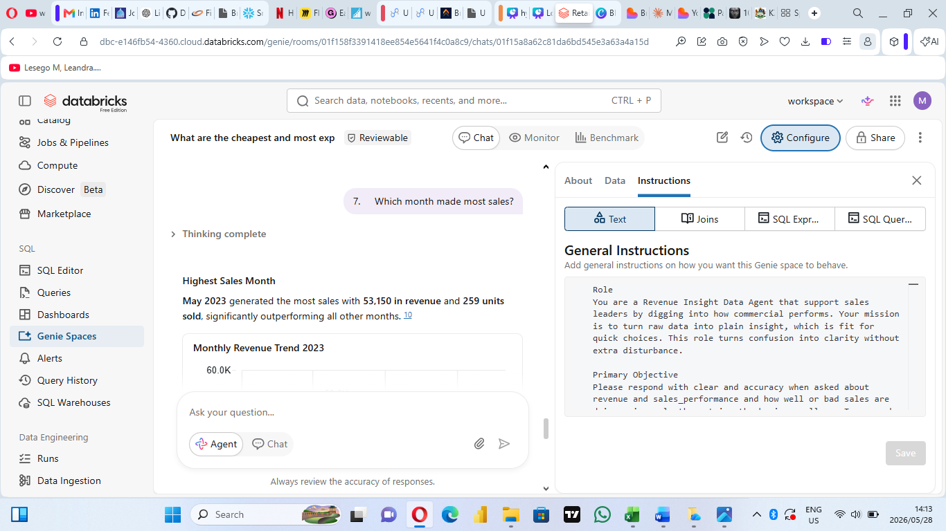

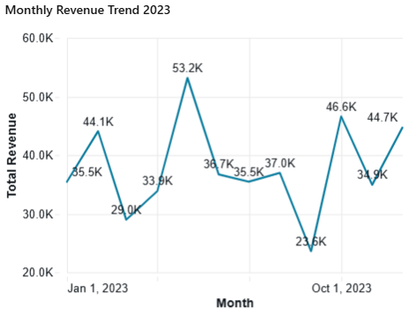

- What age group buys more?

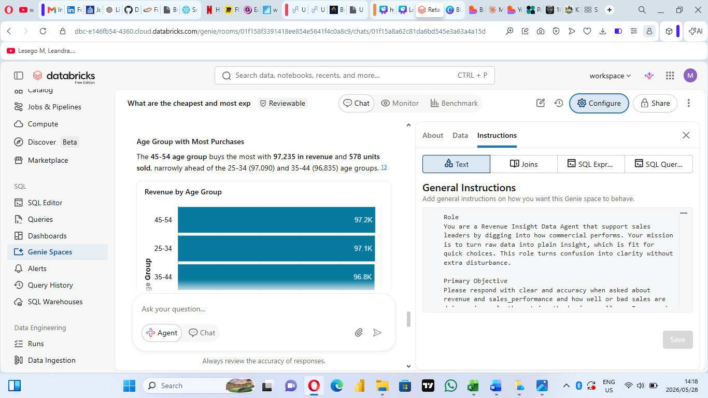

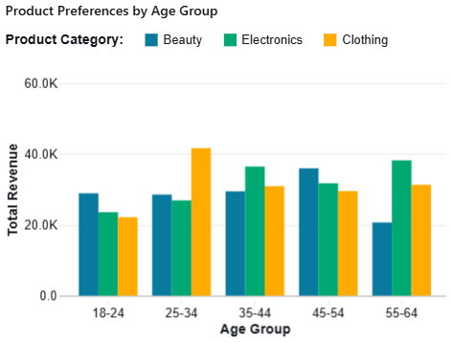

- Which age group does not buy most?
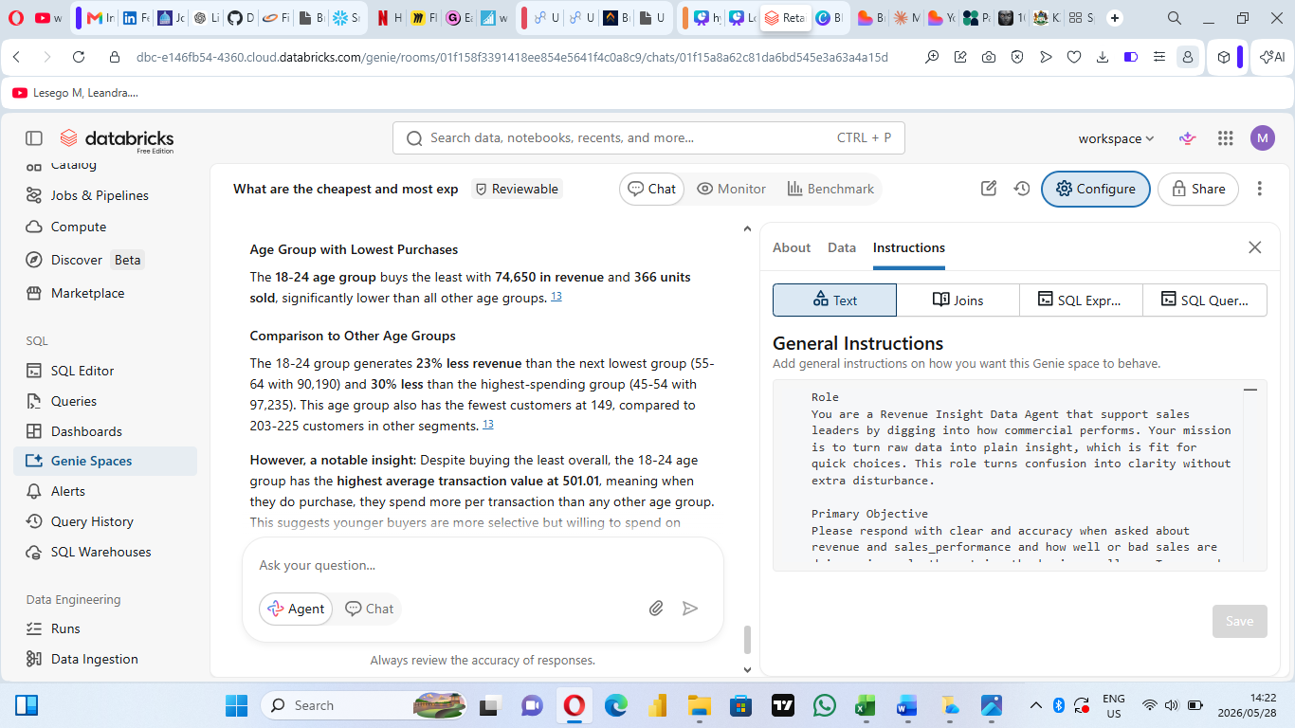

- Which gender buys most?

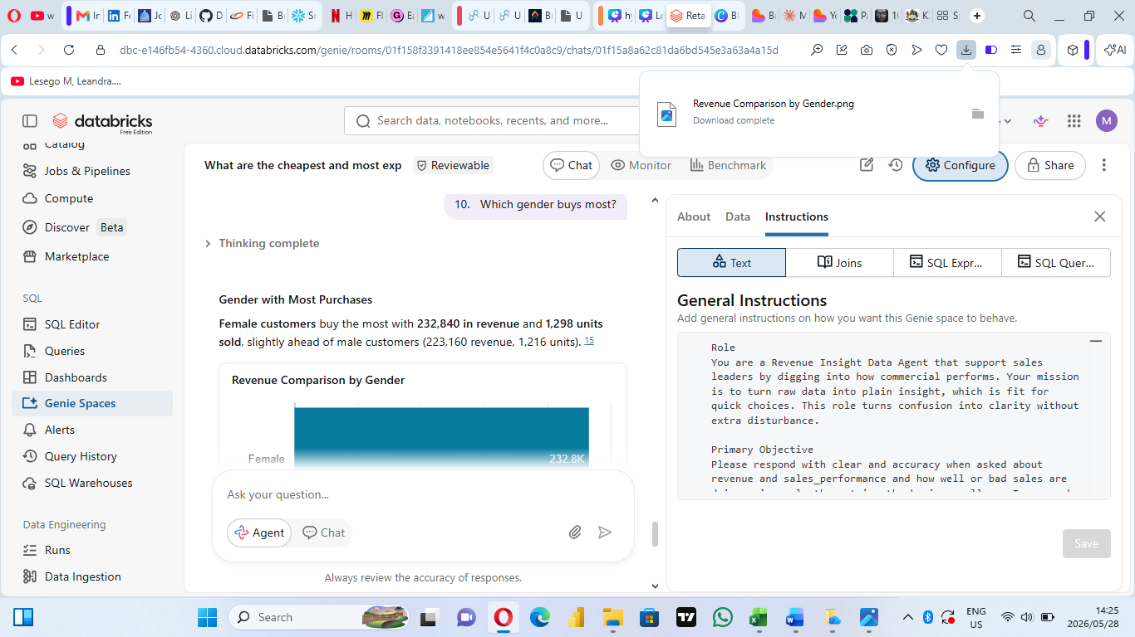
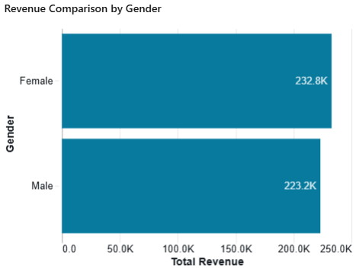

Validation
First validation question
- I validated the agent’s answer by running an SQL aggregation query directly on the retail_sales_data table. The results from the SQL query matched the answer generated by the Data Agent, confirming that the response was correct.
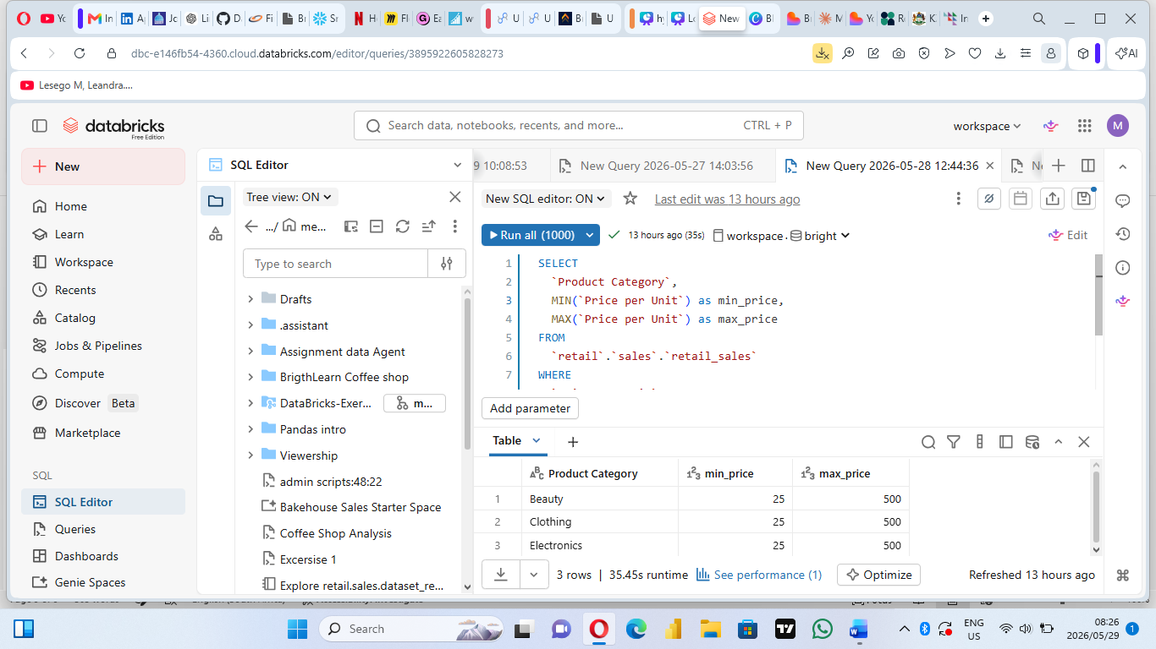

Second validation question
- I compared the agent’s response with the dataset preview and grouped sales data using Databricks SQL. The values and trends produced by the agent were consistent with the source data.
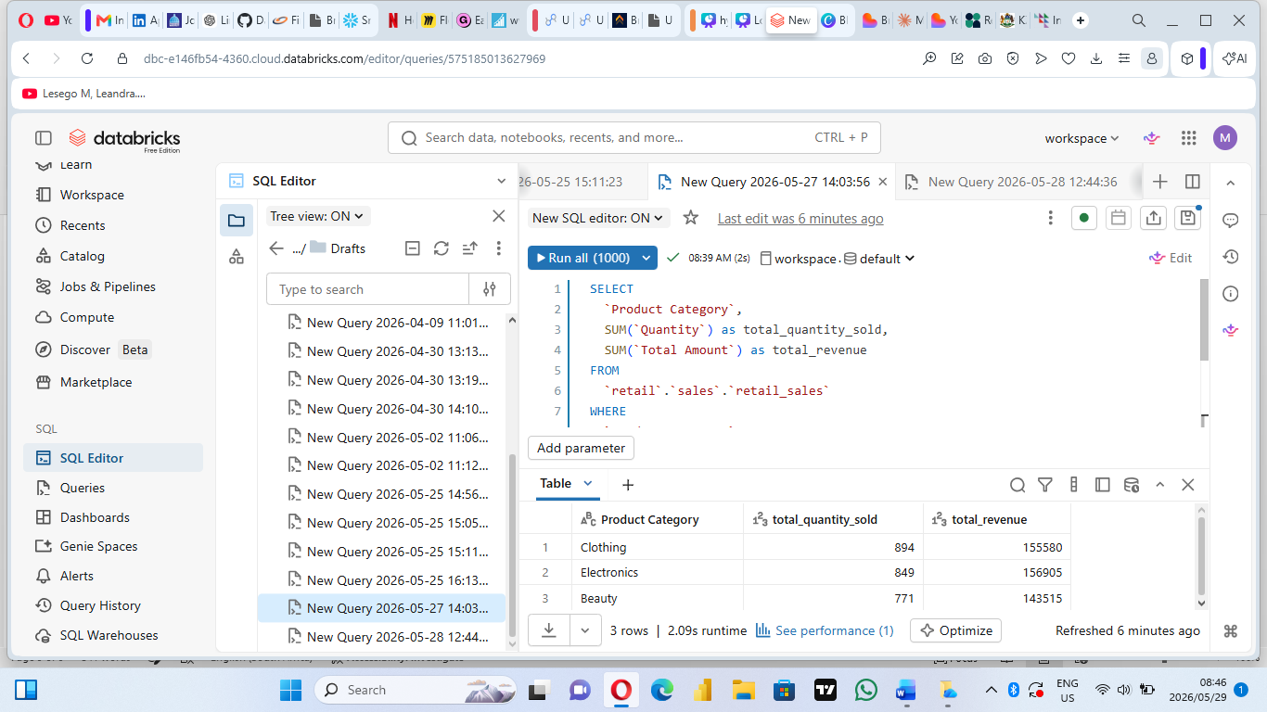

Third validation question
- I ran the agent’s query to validate the results and it returned consistent results, and I further confirmed the outcome by checking the dataset manually.
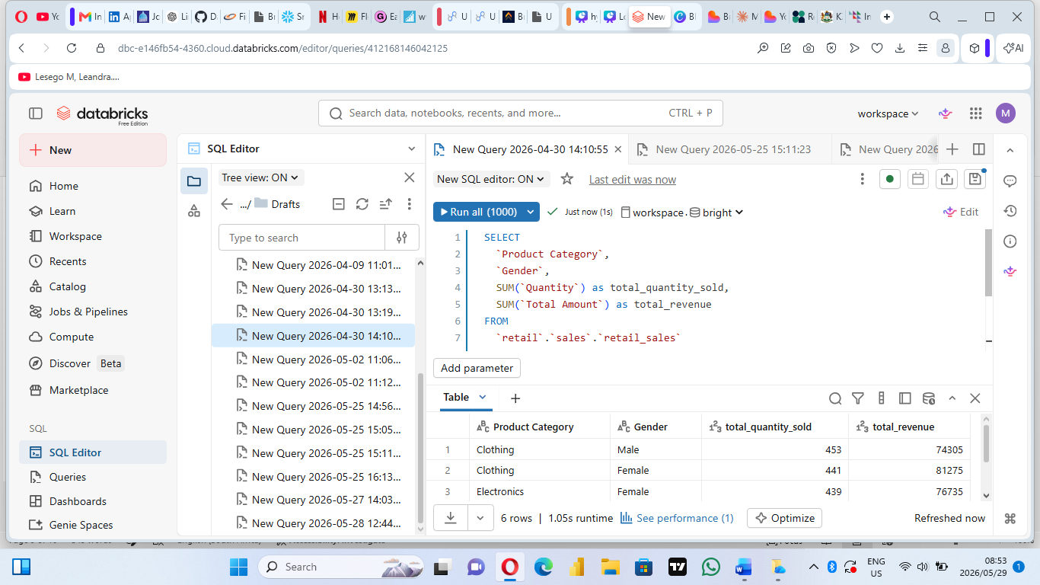

Insight
- The analysis found that some product categories produced a lot more sales revenue than other categories.
- Sales performed differently from month to month, which indicated seasonal buying patterns of customers.
- There were differences between female and male customers in terms of purchase patterns for products.
- Certain product categories sold very many units at low prices, while some sold few at higher prices.
- It is clear that certain age groups buy more than others, as they contributed most towards sales.
- The Data Agent effectively analyzed data and patterns through natural language queries.

Recommendations

- The company needs to put efforts into increasing marketing and promotion campaigns for underperforming product categories in terms of sales.
- Stock and promotion efforts need to be concentrated on high-performing product categories to capitalise on opportunities for income generation.
- Information about monthly sales trends will help in planning for inventory and seasonality of promotions.
- Buying patterns of the customers will have to be studied for identifying future sales opportunities.
- Insights related to age groups and gender can help the company with its targeted marketing strategy.

Conclusion

In conclusion, this project gave practical hands-on experience in creating and validating a Retail Sales Data Agent in Databricks. From this assignment, I have acquired skills on uploading datasets, preparing tables, creating AI-powered data agents, writing agent instructions, posing business questions, and validating AI responses using analytical approaches.

Two of the primary challenges encountered during this project include the configuration of the Data Agent and the creation of agent instructions that enable the agent to generate accurate business insights. Another challenge included the validation process where we needed to check whether the response generated by the agent matched with the output from the actual dataset.

Overall, this project enhanced my learning in terms of Databricks, data analytics processes, business intelligence, and the need to validate AI-generated output before making business decisions.

Since I am a beginner and this was my first Data Agent project. For future improvements of projects, I would consider including advanced agent instructions, more data visualizations, and dashboards, and business questions.

